GIF

📘 Definition
# Source: AI Source: Provided by: [Data Path: Persons Table -> ID Column: 1, Name_En Column: Motasem Essam] -> From: [ChatGPT] on [5/2/2026]
A GIF is a digital image format that supports both static images and short animations. It is commonly used for looping animations, simple graphics, and memes.

🎬 How GIF works
# Source: AI Source: Provided by: [Data Path: Persons Table -> ID Column: 1, Name_En Column: Motasem Essam] -> From: [ChatGPT] on [5/2/2026]

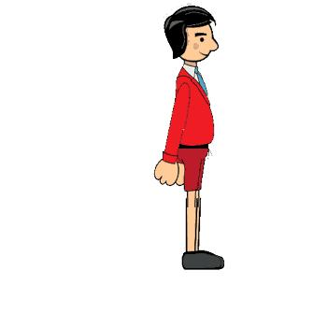
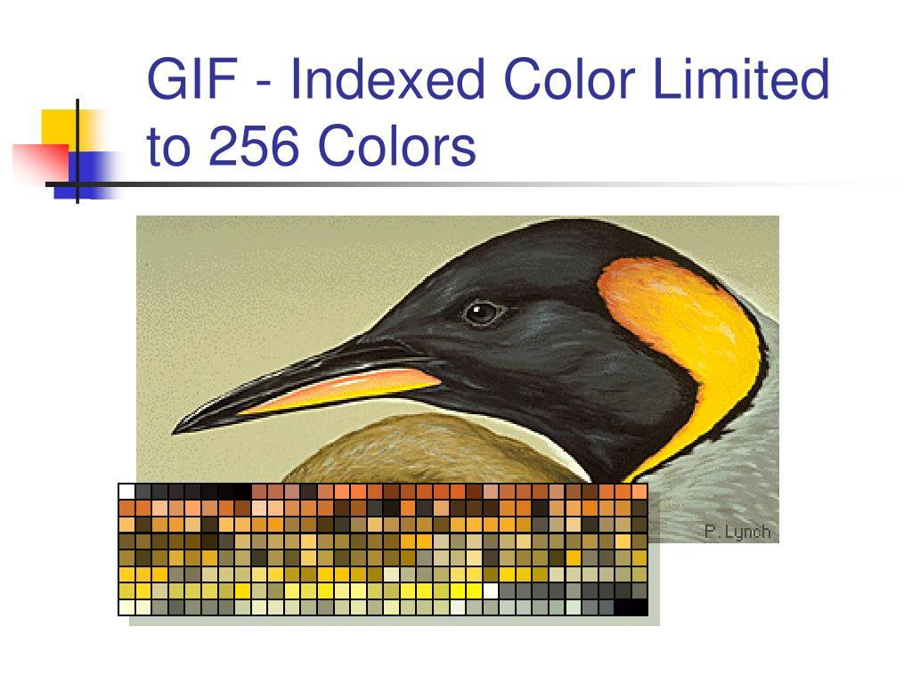
- A GIF is made of multiple images (frames)
- These frames are shown one after another quickly
- This creates a short animation effect
- GIFs can also be static images (no animation)

🧠 Simple example
# Source: AI Source: Provided by: [Data Path: Persons Table -> ID Column: 1, Name_En Column: Motasem Essam] -> From: [ChatGPT] on [5/2/2026]
Think of:
- 😂 A laughing meme that repeats forever
- 🔄 A loading spinner animation
- 🐱 A short looping cartoon clip

🌐 Where GIF is used
# Source: AI Source: Provided by: [Data Path: Persons Table -> ID Column: 1, Name_En Column: Motasem Essam] -> From: [ChatGPT] on [5/2/2026]
- 📱 Social media reactions and memes
- 🌐 Websites (simple animations, icons)
- 🎮 Game UI animations (loading, effects)
- 📊 Tutorials and visual explanations

⚙️ Key features
# Source: AI Source: Provided by: [Data Path: Persons Table -> ID Column: 1, Name_En Column: Motasem Essam] -> From: [ChatGPT] on [5/2/2026]
- 🎞️ Supports animation (looping frames)
- 🎨 Limited to 256 colors
- 🔁 Can loop forever
- 📁 Small file size for simple animations
- 🚫 Not ideal for high-quality photos

🚀 In short:
# Source: AI Source: Provided by: [Data Path: Persons Table -> ID Column: 1, Name_En Column: Motasem Essam] -> From: [ChatGPT] on [5/2/2026]
GIF = a file format that shows simple images or short looping animations using multiple frames.

